# Exercises: Playing with Dash

This document describes the **exercise assignments** for the ["Blockchain Academy" course @ Software University](https://softuni.bg/courses/programming-fundamentals).

## Install Dash Core Wallet

* 1. Go to <https://www.dash.org/wallets/> and download the “Dash Core Installer”.

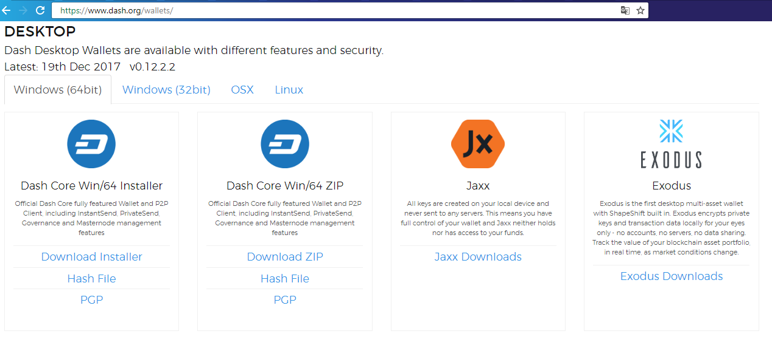

* 1. Start installing the “Dash Core Wallet”. Click [**Next**].

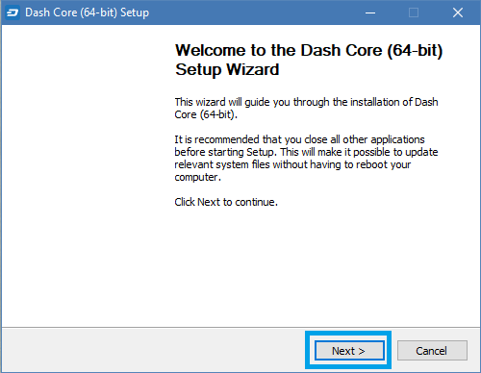

* 1. Choose the directory to save the wallet and click [**Next**].

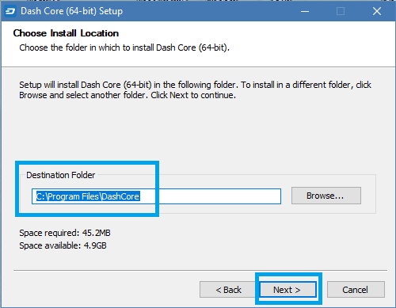

* 1. [**Install**] it.

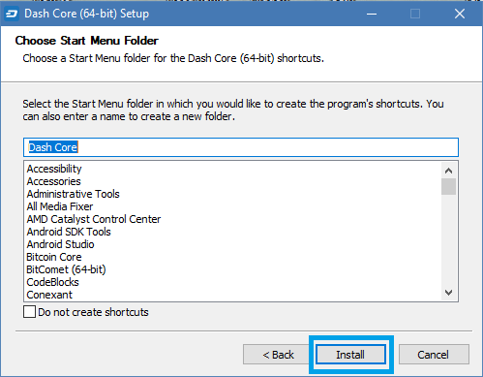

* 1. After installation is complete click [**Next**].

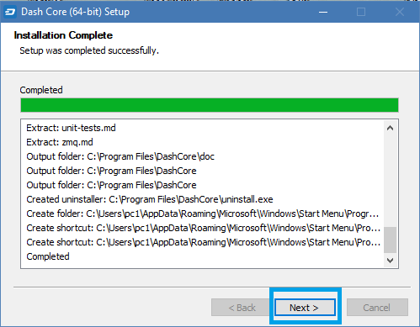

* 1. Finally [**Finish**] the installation.

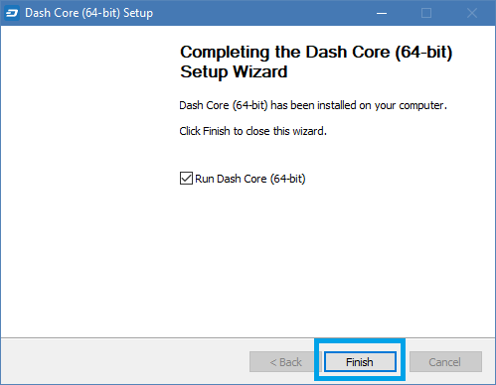

* 1. Run Dash Wallet and you can look at it.

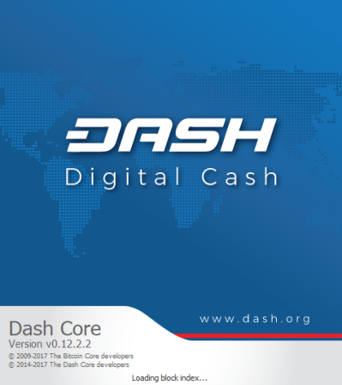

## Install Dash Core Wallet Testnet and Get Test Dashes

* 1. Go to <https://www.dash.org/forum/threads/testnet-tools-resources.1768/> and click one of the links.

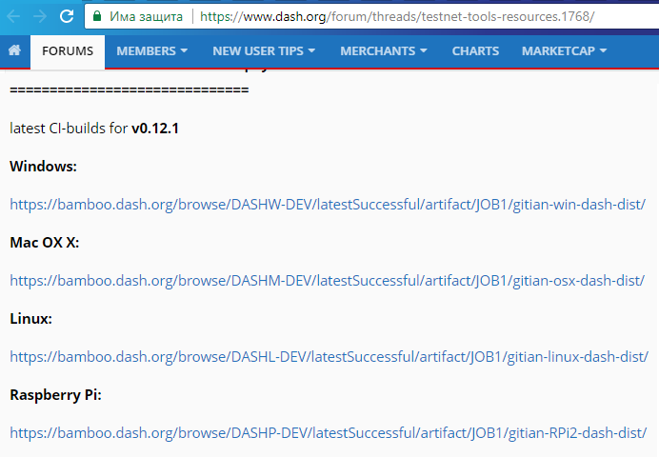

* 1. Download one of the following files:

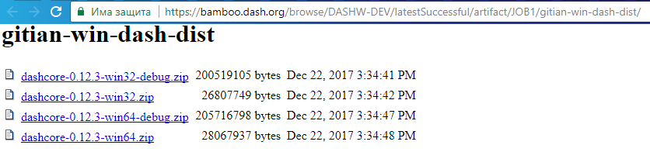

* 1. Go to **C:\Users\user-name\AppData\Roaming\DashCore** and choose the **dash.conf** file.

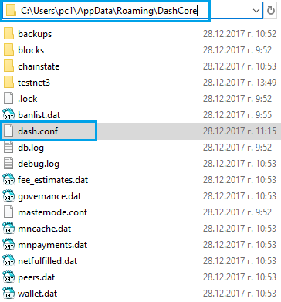

* 1. Write the following and save.

11.png

* 1. Go to where you installed the Dash Core Wallet and start the **dash-qt.exe.**

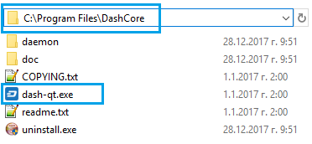

* 1. Start the Testnet Dash Wallet.

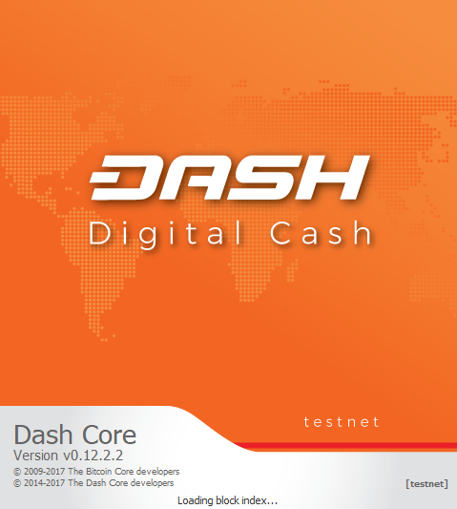

* 1. Choose [**File**] and go to [**Receiving addresses**].

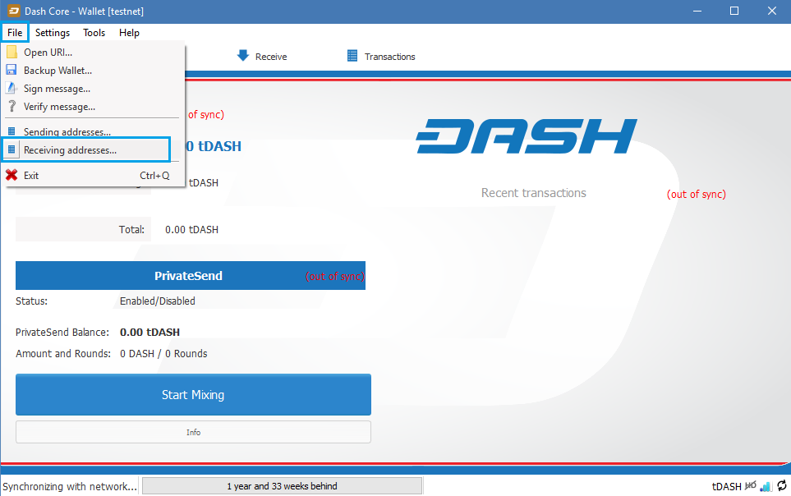

* 1. This is your testnet address for receiving dashes. (The testnet addresses starts with the letter “y”, mainnet – “x”). Copy the address.

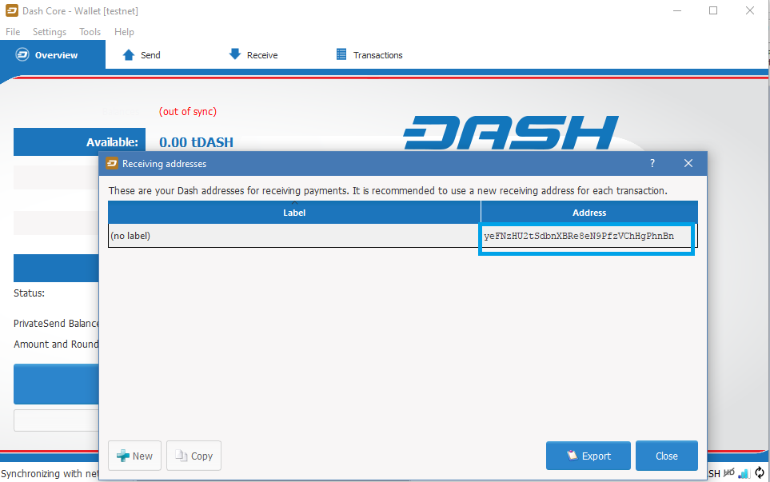

* 1. Go to <https://test.faucet.masternode.io>, paste your testnet address and [**Get coins**].

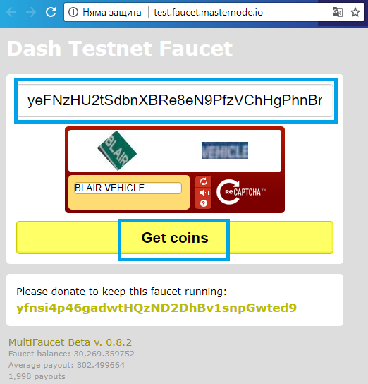

* 1. You should see the following window if everything is successful.

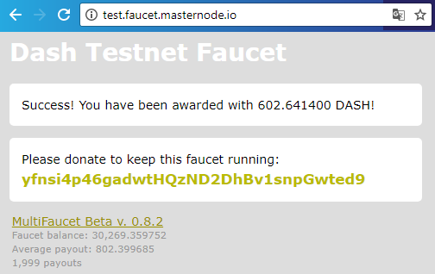

* 1. And you will see the dashes in your wallet.

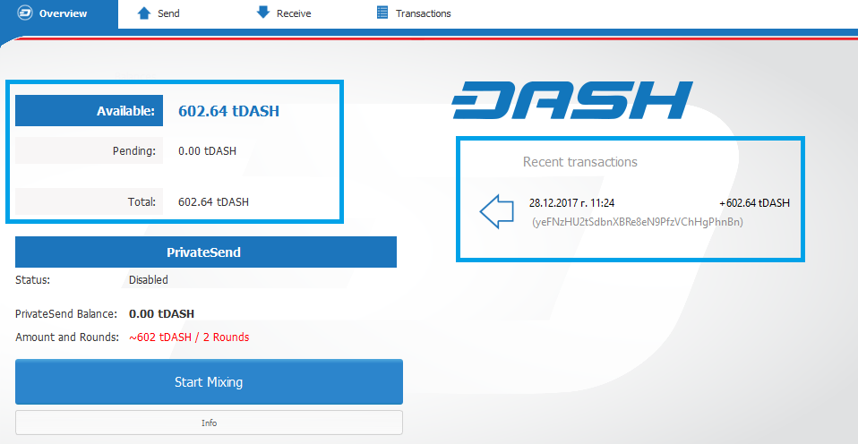

## Send Dashes to Someone

* 1. From the wallet go to [**Send**] tab, paste someone's address, write some message in the label textbox, choose an amount to send and click [**Send**]. You can choose the transaction to be “PrivateSend”, “InstantSend” or both.

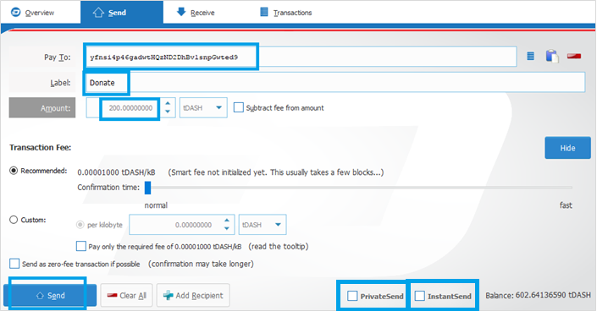

* 1. Click [**Yes**].

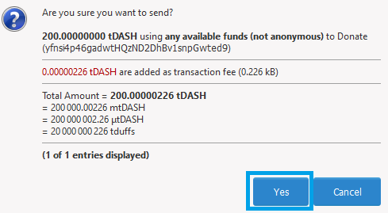

* 1. Your dashes should be -200 and will see the transaction on the right if everything is successful.

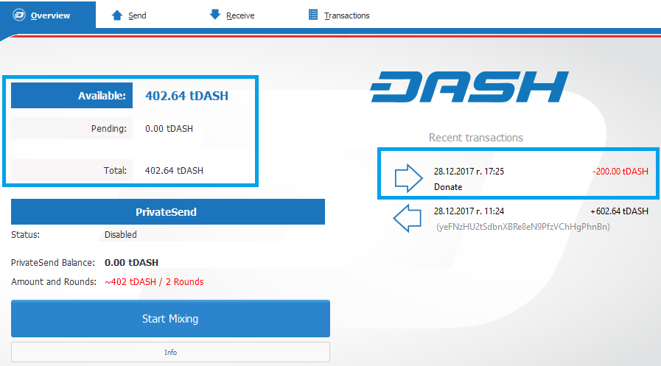

* 1. In [**Transactions**] tab, you can see the transaction you have made so far.

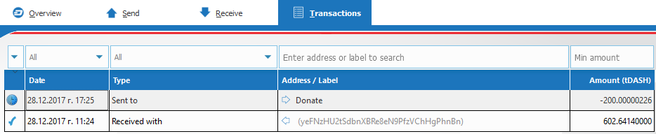

Congratulations!   
Now you have installed Dash Core Wallet, you have main net and testnet address, and you know how to receive and send transactions.